NAME: MONIKA.B
REG . NO:192571002
Question 1 - Identify and correct errors in a given SQL CREATE TABLE statement with incorrect syntax and missing constraints. (BL2 – Understand)
Step 1: Faulty Query
CREATE TABLE StudentsNew (
RollNo,
Name TEXT
Course TEXT,
Marks INT DEFAULT
);
Screenshot 1 — Query executed in SQL compiler (Before Fix):
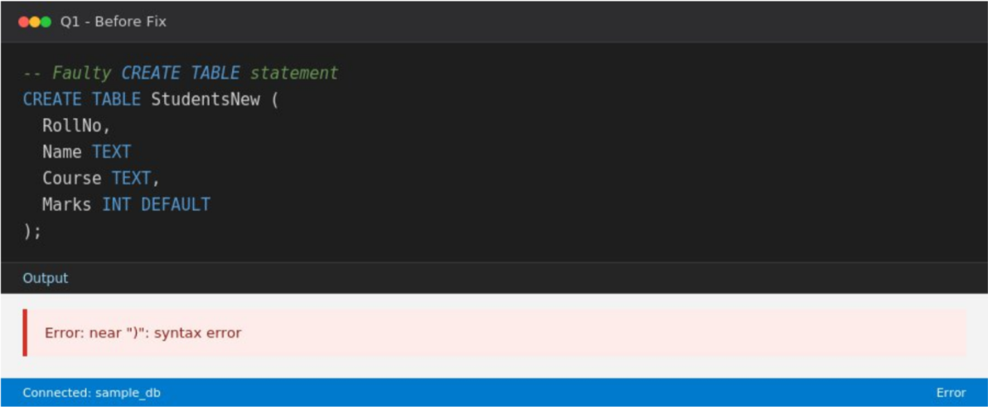
Step 2: Errors Identified
- A comma is missing after the "Name TEXT" column definition, so the parser cannot separate it from the next column ("Course TEXT").
- The RollNo column has no data type specified.
- The Marks column uses "DEFAULT" without providing an actual default value, which is invalid syntax.
- No PRIMARY KEY constraint is defined for RollNo, and no NOT NULL constraints are applied to mandatory columns.
Step 3: Corrected Query
CREATE TABLE StudentsNew (
RollNo INT PRIMARY KEY,
Name TEXT NOT NULL,
Course TEXT NOT NULL,
Marks INT DEFAULT 0
);
Screenshot 2 — Query executed in SQL compiler (After Fix):
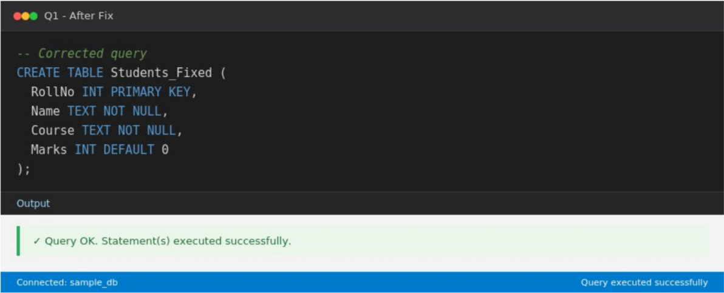
Step 4: Analysis
The faulty statement fails with a syntax error at the closing parenthesis because the missing comma and the incomplete DEFAULT clause make the statement unparsable. After adding the missing comma, specifying INT for RollNo, giving DEFAULT a value (0), adding PRIMARY KEY on RollNo, and NOT NULL on mandatory columns, the table is created successfully as confirmed by the "Query OK" output.

Question 2 - Debug an SQL query that incorrectly uses aggregate functions without GROUP BY and fix the issue.
Step 1: Faulty Query
SELECT DeptID, AVG(Salary)
FROM Employees;
Screenshot 1 — Query executed in SQL compiler (Before Fix):
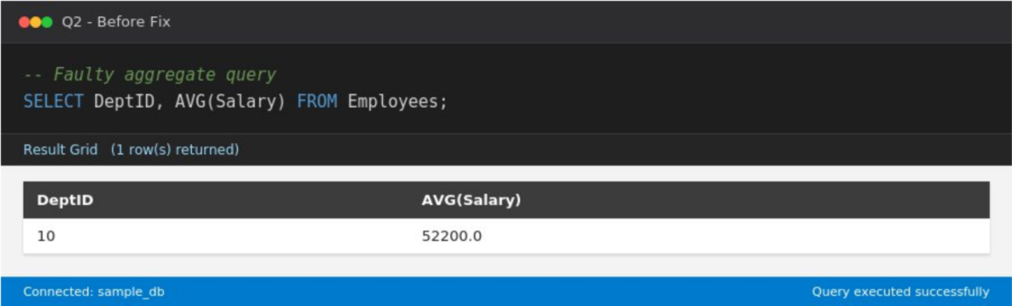
Step 2: Errors Identified
- DeptID is a non-aggregated column selected alongside the aggregate function AVG(Salary) without a GROUP BY clause.
- Because there is no GROUP BY, the engine collapses all rows into a single group, so only one arbitrary DeptID is shown together with one overall average — the per-department averages are lost.
- In stricter SQL engines (e.g. MySQL with ONLY_FULL_GROUP_BY, or Oracle/SQL
Server) this raises an explicit error instead of silently returning a misleading single row.
Step 3: Corrected Query
SELECT DeptID, AVG(Salary) AS AvgSalary
FROM Employees
GROUP BY DeptID;
Screenshot 2 — Query executed in SQL compiler (After Fix):
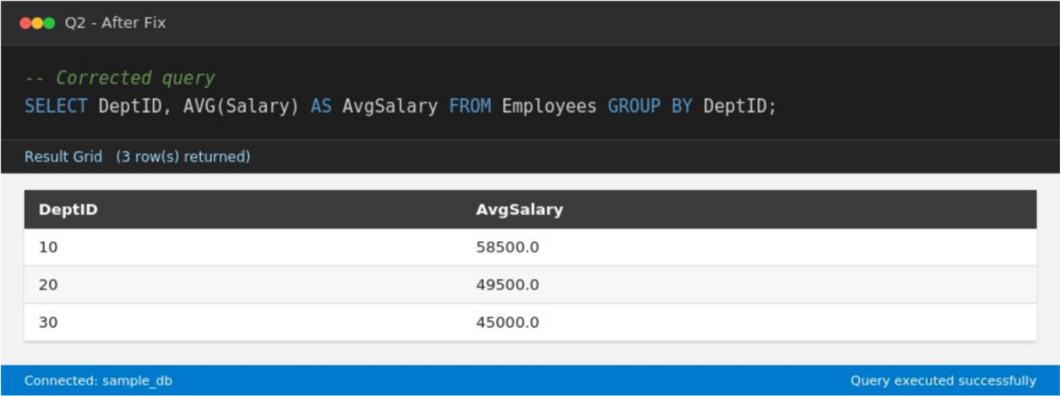
Step 4: Analysis
The faulty query returns only one row (DeptID 10 with a blended average of 51833.33) even though there are three departments — this hides the true per-department averages, which is the bug. Adding GROUP BY DeptID makes the aggregate function operate per department, correctly returning one row per DeptID with its own average salary (Screenshot 2 shows three rows, one for each department).
Question 3
Correct a faulty SELECT query where column names are misspelled or improperly referenced. (BL1 – Remember)
Step 1: Faulty Query
SELECT EmpNam, Sal
FROM Employees;
Screenshot 1 — Query executed in SQL compiler (Before Fix):
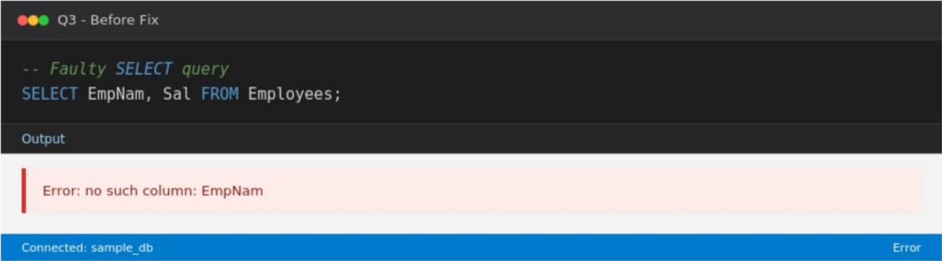
Step 2: Errors Identified
- "EmpNam" is misspelled — the actual column is "EmpName".
- "Sal" is misspelled — the actual column is "Salary".
- Because these columns do not exist in the Employees table, the query fails with a "no such column" error.
Step 3: Corrected Query
SELECT EmpName, Salary
FROM Employees;
Screenshot 2 — Query executed in SQL compiler (After Fix):
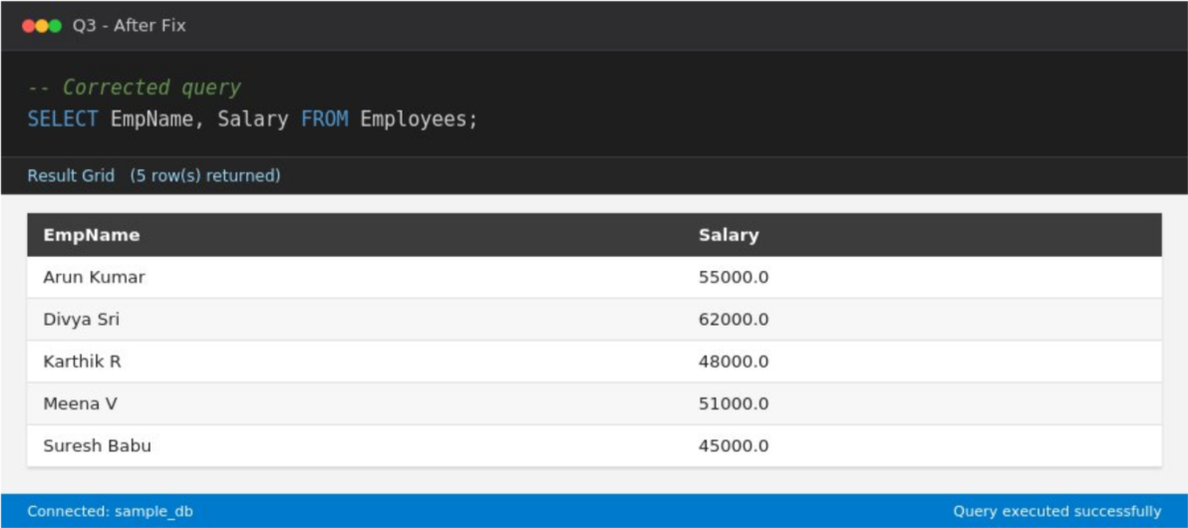
Step 4: Analysis
The faulty query fails immediately with a "no such column: EmpNam" error since the compiler cannot resolve the misspelled identifier. Correcting the spelling to match the actual schema (EmpName, Salary) allows the query to execute and return all five employee records with their names and salaries.
Question 4 - Fix errors in an SQL query using JOIN, where the join condition is missing or incorrect.
Step 1: Faulty Query
SELECT Employees.EmpName, Departments.DeptName
FROM Employees, Departments;
Screenshot 1 — Query executed in SQL compiler (Before Fix):
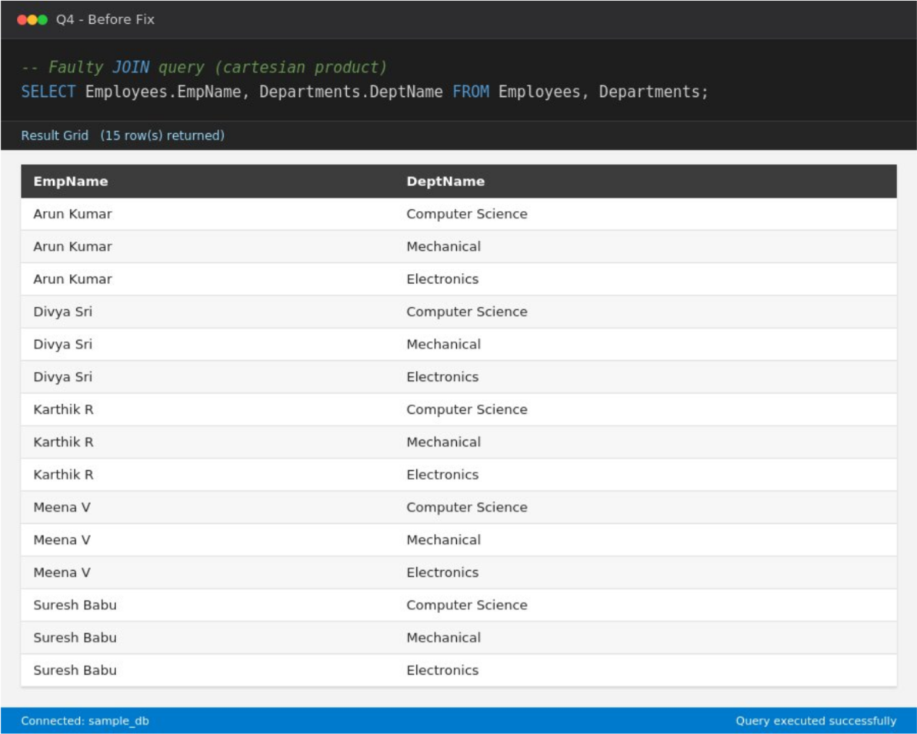
Step 2: Errors Identified
- The query lists Employees and Departments separated by a comma but never specifies how the two tables are related.
- Without an ON / WHERE condition, the compiler performs a Cartesian product, pairing every employee row with every department row.
- With 5 employees and 3 departments this incorrectly returns 15 rows instead of the expected 5 (one correctly-matched row per employee).
Step 3: Corrected Query
SELECT E.EmpName, D.DeptName
FROM Employees E
JOIN Departments D ON E.DeptID = D.DeptID;
Screenshot 2 — Query executed in SQL compiler (After Fix):
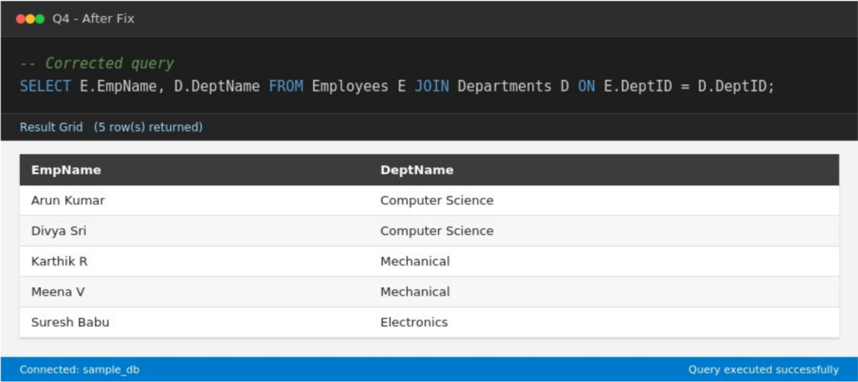
Step 4: Analysis
The faulty query executes without an error but returns 15 rows — a classic silent bug caused by a missing join condition (visible in Screenshot 1, where every employee is matched with every department). Adding the explicit JOIN ... ON E.DeptID = D.DeptID condition restricts each employee to only their own department, correctly returning 5 rows.
Question 5
Identify and correct a subquery error where multiple values are returned instead of a single value. (BL2 – Understand) Step 1: Faulty Query
SELECT EmpName FROM Employees
WHERE DeptID = (
SELECT DeptID FROM Departments WHERE Location = 'Chennai'
);
Screenshot 1 — Query executed in SQL compiler (Before Fix):
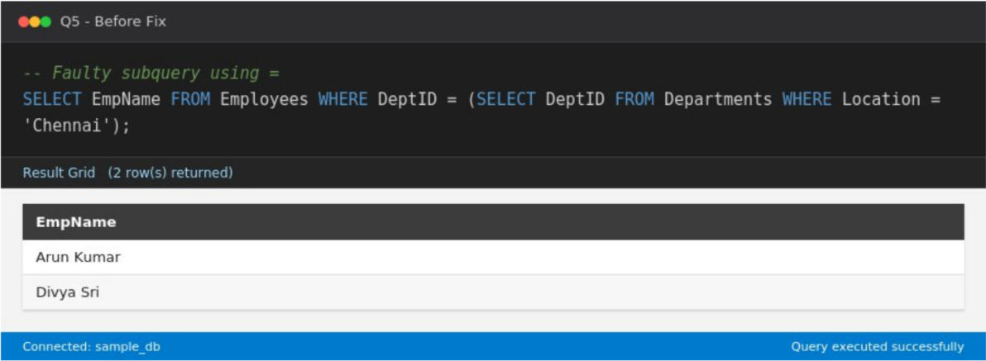
Step 2: Errors Identified
- The outer query compares DeptID to a subquery using "=", which expects the subquery to return a single value.
- The subquery "SELECT DeptID FROM Departments WHERE Location = 'Chennai'" actually returns two rows (DeptID 10 and DeptID 20 are both located in Chennai).
- This mismatch means the comparison is logically invalid — many SQL engines reject it outright with a "subquery returns more than one row" error, and even where it is silently tolerated, only one arbitrary department is used, so matching employees from the other Chennai department are wrongly excluded.
Step 3: Corrected Query
SELECT EmpName
FROM Employees
WHERE DeptID IN (
SELECT DeptID FROM Departments WHERE Location = 'Chennai'
);
Screenshot 2 — Query executed in SQL compiler (After Fix):
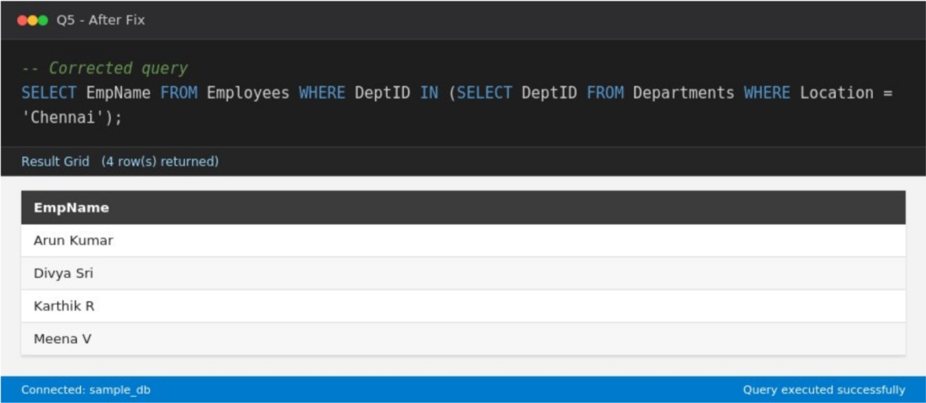
Step 4: Analysis
Screenshot 1 shows only 2 employees returned (from a single Chennai department), silently omitting Karthik R and Meena V, who also belong to a Chennai department (Mechanical, DeptID 20). Replacing "=" with "IN" allows the outer query to correctly compare DeptID against the full set of values returned by the subquery, and Screenshot 2 shows all 4 employees from both Chennai departments being returned.
Question 6 - Debug a VIEW creation statement that contains invalid column references or syntax errors.
Step 1: Faulty Query
CREATE VIEW EmpView AS
SELECT EmpNam, Salry, DeptID
FROM Employees;
Screenshot 1 — Query executed in SQL compiler (Before Fix):
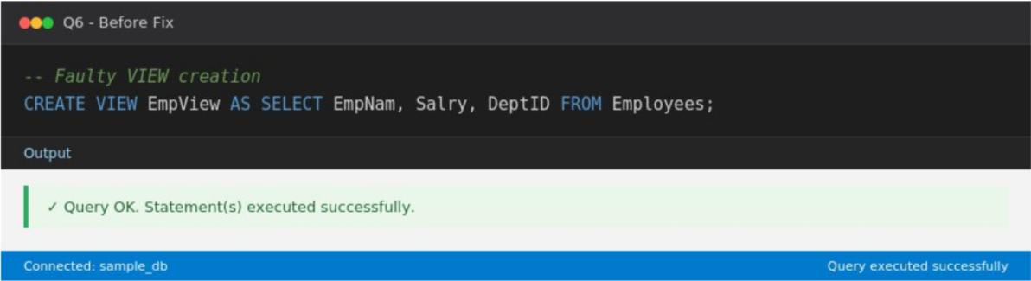
Step 2: Errors Identified
- "EmpNam" is misspelled — should be "EmpName".
- "Salry" is misspelled — should be "Salary".
- Because the referenced columns do not exist, the CREATE VIEW statement fails with a "no such column" error and the view is never created.
Step 3: Corrected Query
CREATE VIEW EmpView AS
SELECT EmpName, Salary, DeptID
FROM Employees;
Screenshot 2 — Query executed in SQL compiler (After Fix):
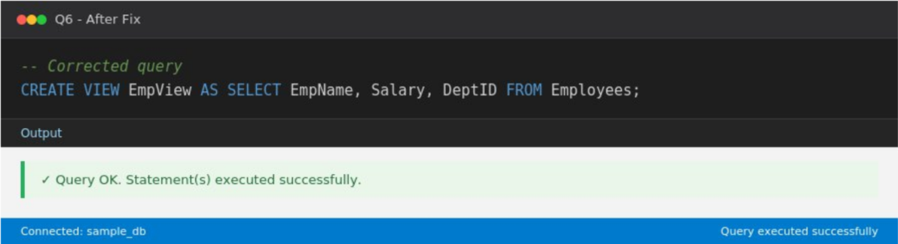
Step 4: Analysis
The faulty CREATE VIEW statement fails to compile because it references non-existent columns. Correcting the column names to EmpName and Salary allows the view to be created successfully, as confirmed by the "Query OK" output in Screenshot 2.
Question 7 - Examine an SQL query with unnecessary conditions and optimize it by simplifying the WHERE clause.
Step 1: Faulty Query
SELECT * FROM Employees
WHERE Salary > 0 AND Salary >= 0 AND DeptID = DeptID AND 1 = 1;
Screenshot 1 — Query executed in SQL compiler (Before Fix):
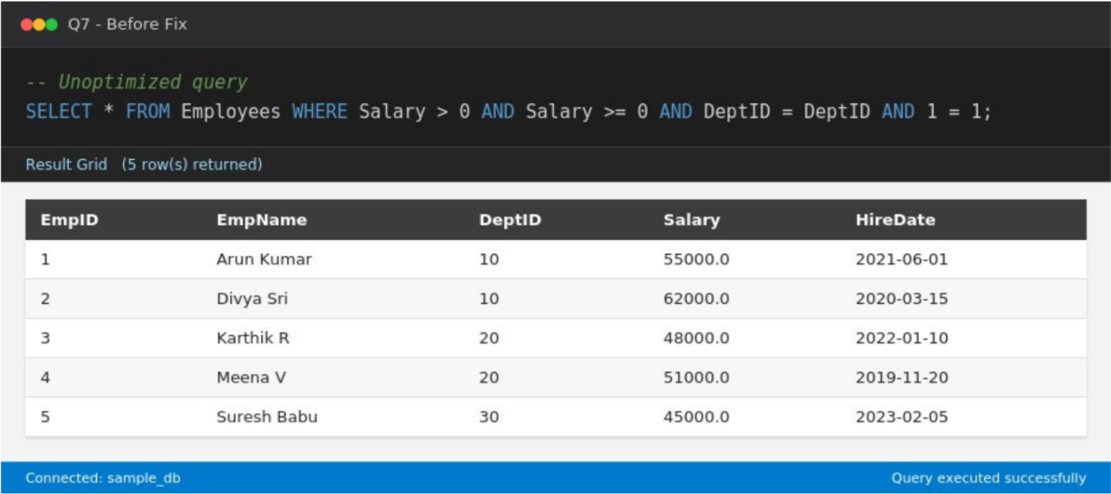
Step 2: Errors Identified
- "Salary >= 0" is redundant once "Salary > 0" is already present — any value satisfying the second automatically satisfies the first.
- "DeptID = DeptID" always evaluates to true (a tautology) for any non-NULL DeptID and adds no filtering value.
- "1 = 1" is a constant tautology and contributes nothing to the filter logic.
- These extra predicates force the optimizer to evaluate additional conditions on every row without changing the result, which is inefficient.
Step 3: Corrected Query
SELECT * FROM Employees
WHERE Salary > 0;
Screenshot 2 — Query executed in SQL compiler (After Fix):
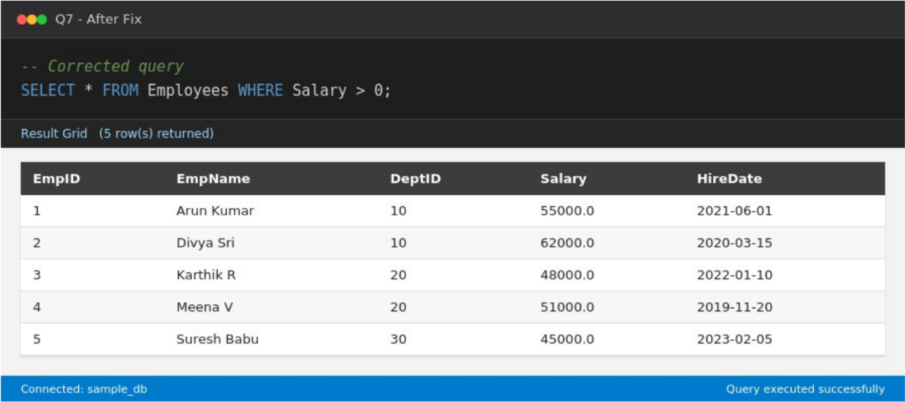
Step 4: Analysis
Both the original and simplified queries return the same 5 rows (Screenshots 1 and 2 show identical result sets), which confirms that the removed conditions were logically redundant. The simplified WHERE clause reduces the number of comparisons the engine must perform per row, improving query efficiency without changing correctness.

Question 8 - Identify violations of integrity constraints in a given table and correct them.
Step 1: Faulty Query
INSERT INTO Employees (EmpID, EmpName, DeptID, Salary, HireDate)
VALUES (1, 'Ramesh', 10, 50000, '2024-01-01');
Screenshot 1 — Query executed in SQL compiler (Before Fix):
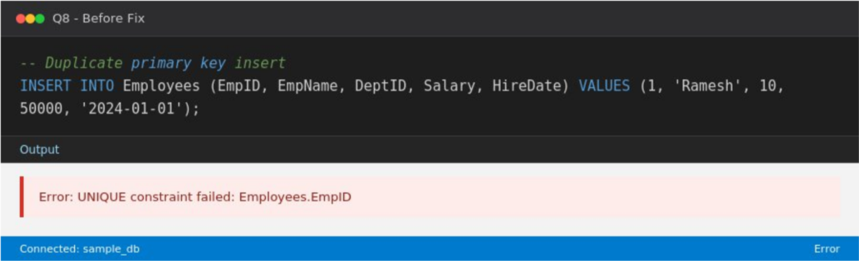
Step 2: Errors Identified
- The Employees table defines EmpID as the PRIMARY KEY, so every value in that column must be unique.
- The INSERT statement attempts to insert EmpID = 1, but a row with EmpID = 1 (Arun
Kumar) already exists.
- This violates the primary key (uniqueness) constraint, so the insert is rejected by the database engine.
Step 3: Corrected Query
INSERT INTO Employees (EmpID, EmpName, DeptID, Salary, HireDate)
VALUES (6, 'Ramesh', 10, 50000, '2024-01-01');
Screenshot 2 — Query executed in SQL compiler (After Fix):
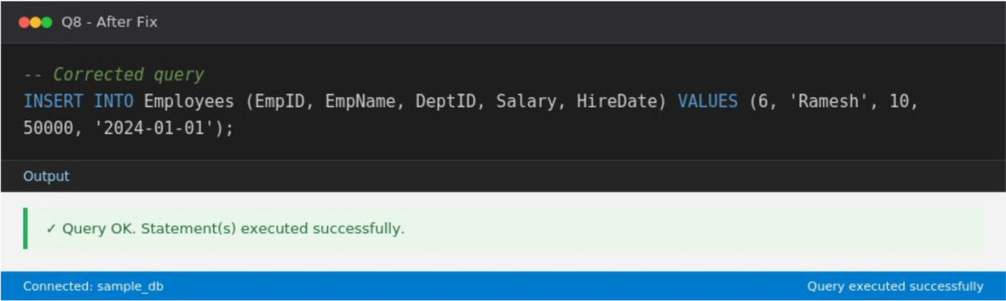
Step 4: Analysis
The faulty INSERT fails with a "UNIQUE constraint failed: Employees.EmpID" error, correctly demonstrating that the primary key constraint is protecting data integrity. Using a new, unused EmpID (6) instead of the duplicate value 1 allows the row to be inserted successfully, as shown by the "Query OK" output in Screenshot 2.

Question 9 - Fix a relation that violates 1NF or 2NF by removing repeating groups or partial dependencies.
Step 1: Faulty Query
CREATE TABLE StudentCourses (
RollNo INT,
Name TEXT,
Courses TEXT -- e.g. 'DBMS, OS, CN' (repeating group)
);
Screenshot 1 — Query executed in SQL compiler (Before Fix):
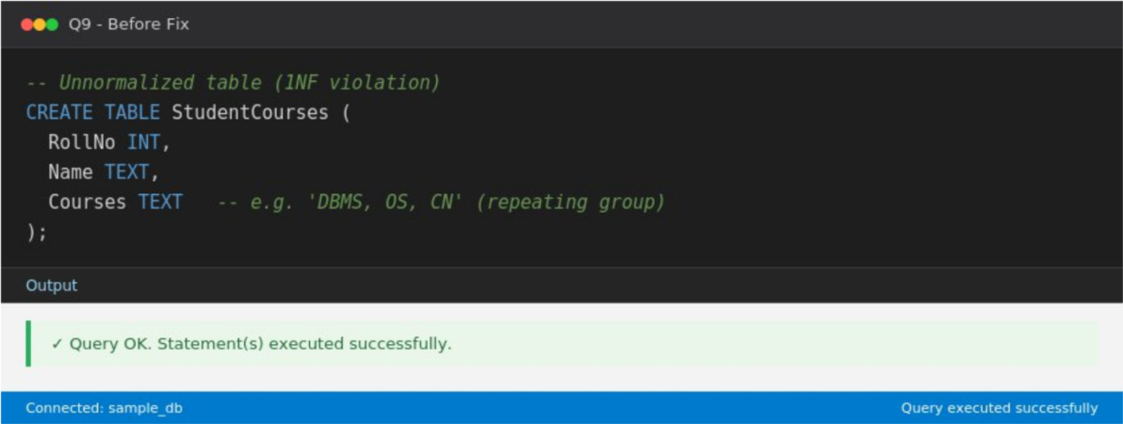
Step 2: Errors Identified
- The Courses column stores multiple course names in a single comma-separated field (e.g. 'DBMS, OS, CN'), which is a repeating group and violates First Normal Form (1NF), which requires atomic, single-valued attributes.
- This design also makes it hard to query, index, or enforce integrity for individual course enrolments.
Step 3: Corrected Query
CREATE TABLE Student (
RollNo INT PRIMARY KEY,
Name TEXT NOT NULL
);
CREATE TABLE StudentCourse (
RollNo INT,
CourseName TEXT,
PRIMARY KEY (RollNo, CourseName),
FOREIGN KEY (RollNo) REFERENCES Student(RollNo)
);
Screenshot 2 — Query executed in SQL compiler (After Fix):
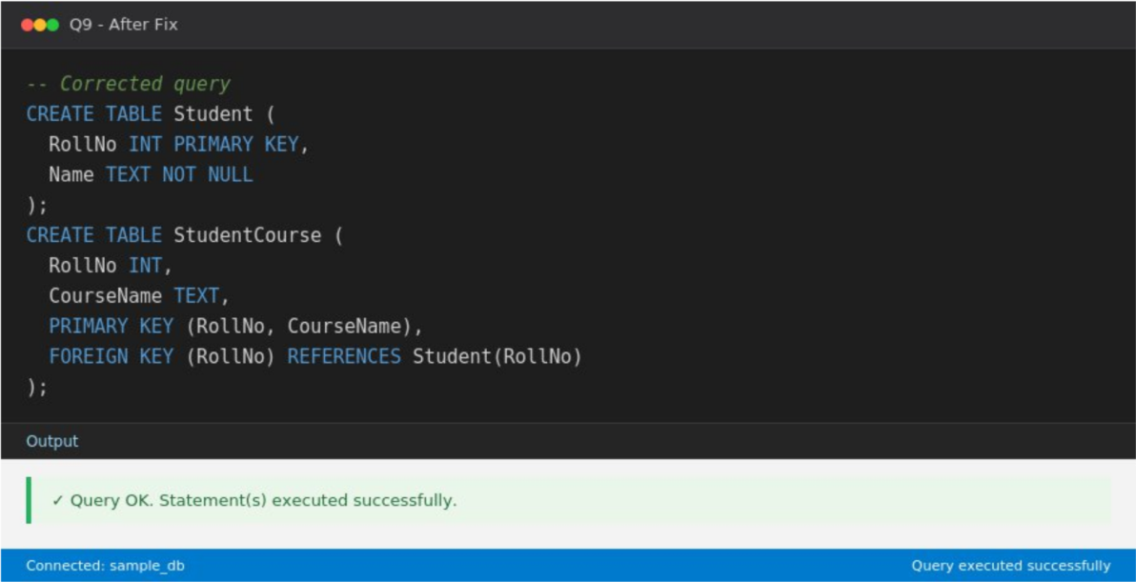
Step 4: Analysis
Screenshot 1 shows the original unnormalized table being created with a single Courses column intended to hold repeating values — a 1NF violation. Screenshot 2 shows the corrected design decomposed into two tables: Student (one row per student) and StudentCourse (one row per student-course pairing), which removes the repeating group and lets each course enrolment be stored, queried, and constrained independently.

Question 10 - Identify redundant attributes in a relation and apply basic normalization (up to 3NF) to improve design.
Step 1: Faulty Query
CREATE TABLE EmployeeDept (
EmpID INT PRIMARY KEY,
EmpName TEXT,
DeptID INT,
DeptName TEXT, -- depends on DeptID, not EmpID (transitive)
Location TEXT -- depends on DeptID, not EmpID (transitive)
);
Screenshot 1 — Query executed in SQL compiler (Before Fix):
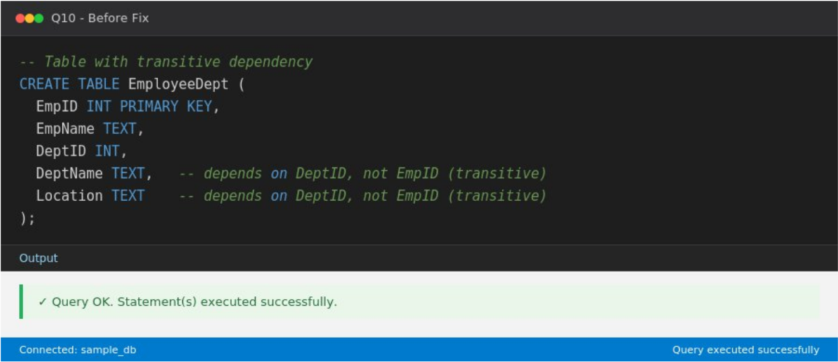
Step 2: Errors Identified
- DeptName and Location depend only on DeptID, not directly on the primary key EmpID — this is a transitive dependency (EmpID → DeptID → DeptName/Location).
- Because of this, DeptName and Location are redundantly repeated for every employee in the same department, wasting storage and risking update anomalies (e.g. updating a department's location in one row but not others).
- This violates Third Normal Form (3NF), which requires that non-key attributes depend only on the primary key, not on other non-key attributes.
Step 3: Corrected Query
CREATE TABLE Employee3NF (
EmpID INT PRIMARY KEY,
EmpName TEXT,
DeptID INT REFERENCES Department3NF(DeptID)
);
CREATE TABLE Department3NF (
DeptID INT PRIMARY KEY,
DeptName TEXT,
Location TEXT
);
Screenshot 2 — Query executed in SQL compiler (After Fix):
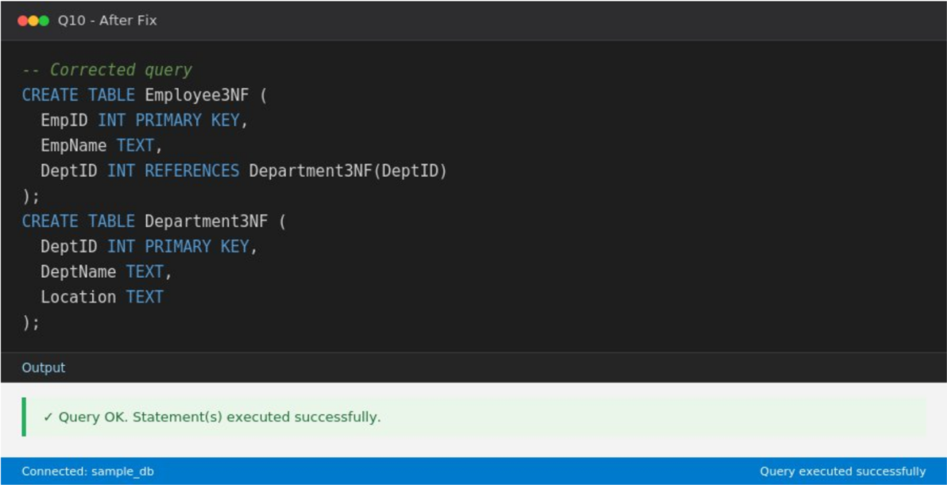
Step 4: Analysis
Screenshot 1 shows the original EmployeeDept table where DeptName and Location are stored redundantly alongside every employee. Screenshot 2 shows the corrected 3NF design, split into Employee3NF (employee facts keyed by EmpID) and Department3NF (department facts keyed by DeptID), removing the transitive dependency — department details are now stored once per department and linked via a foreign key.

